**Matlab Code for Pulse Width Modulation and Pulse Position Modulation**

fm=25;

w=2*pi;

f=300;

overSampRate=650;

fs=overSampRate*f;

cycle=50;

t=0:1/fs:0.1;

%%Message Signal

xm= sin(w*fm*t);

subplot(4,1,1);

plot(t,xm);

title('Message Signal');

%%Carrier Pulse Signal

xc=2*sawtooth(800*t);

subplot(4,1,2);

plot(t,xc);

title('Carrier Pulse Signal');

%%Pulse Width Modulation

for i= 1:length(t)

if xc(i) <= xm(i)

pw(i)=1;

else

pw(i)=0;

end

end

subplot(4,1,3);

plot(t,pw);

title('Pulse Width Modulated wave');

%%Pulse Position Modulation

pp(1)=0;

for i=2:length(t)

if pw(i)==pw(i-1)

pp(i)=0;

elseif pw(i) < pw(i-1)

pp(i)=1;

end

end

subplot(4,1,4)

plot(t,pp)

title('Pulse Position Modulated wave');

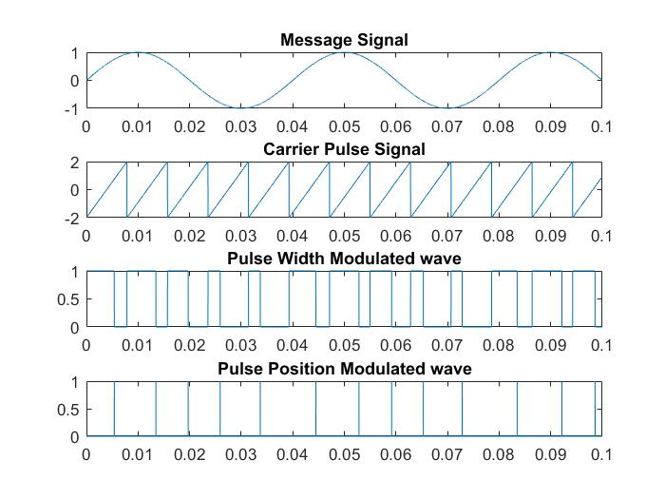

**Matlab Code for Pulse Width Modulation and Pulse Position Modulation**

fm=25;

w=2*pi;

f=300;

overSampRate=650;

fs=overSampRate*f;

cycle=50;

t=0:1/fs:0.1;

%%Message Signal

xm= sin(w*fm*t);

subplot(4,1,1);

plot(t,xm);

title('Message Signal');

%%Carrier Pulse Signal

xc=2*sawtooth(800*t);

subplot(4,1,2);

plot(t,xc);

title('Carrier Pulse Signal');

%%Pulse Width Modulation

for i= 1:length(t)

if xc(i) <= xm(i)

pw(i)=1;

else

pw(i)=0;

end

end

subplot(4,1,3);

plot(t,pw);

title('Pulse Width Modulated wave');

%%Pulse Position Modulation

pp(1)=0;

for i=2:length(t)

if pw(i)==pw(i-1)

pp(i)=0;

elseif pw(i) < pw(i-1)

pp(i)=1;

end

end

subplot(4,1,4)

plot(t,pp)

title('Pulse Position Modulated wave');